- Diffe-Hellman Output:
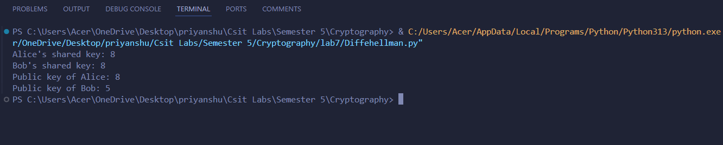

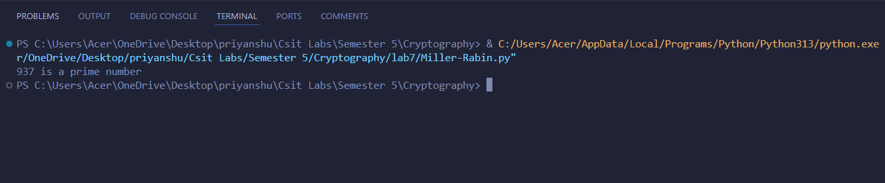
- Miller-Rabin Output:

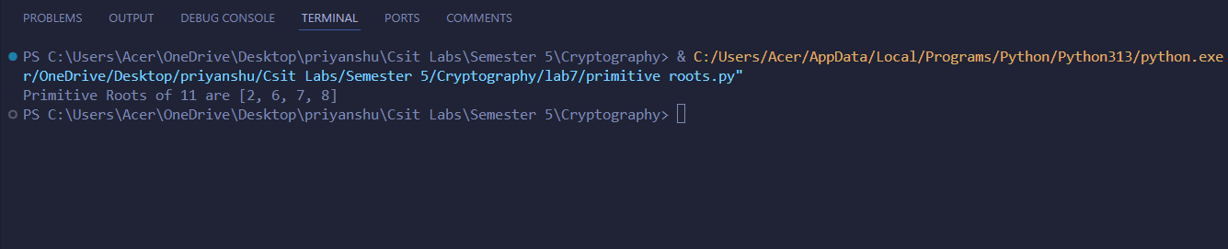
- Primitive Roots Output:

- Uiler’s Toitent Function:
